Louise Bassog

Dr. Bemley

CTEC 298

10/27/2022

Learn python tutorial part 1

Hello World

Variables and Types

Lists

Basic Operators

String formatting

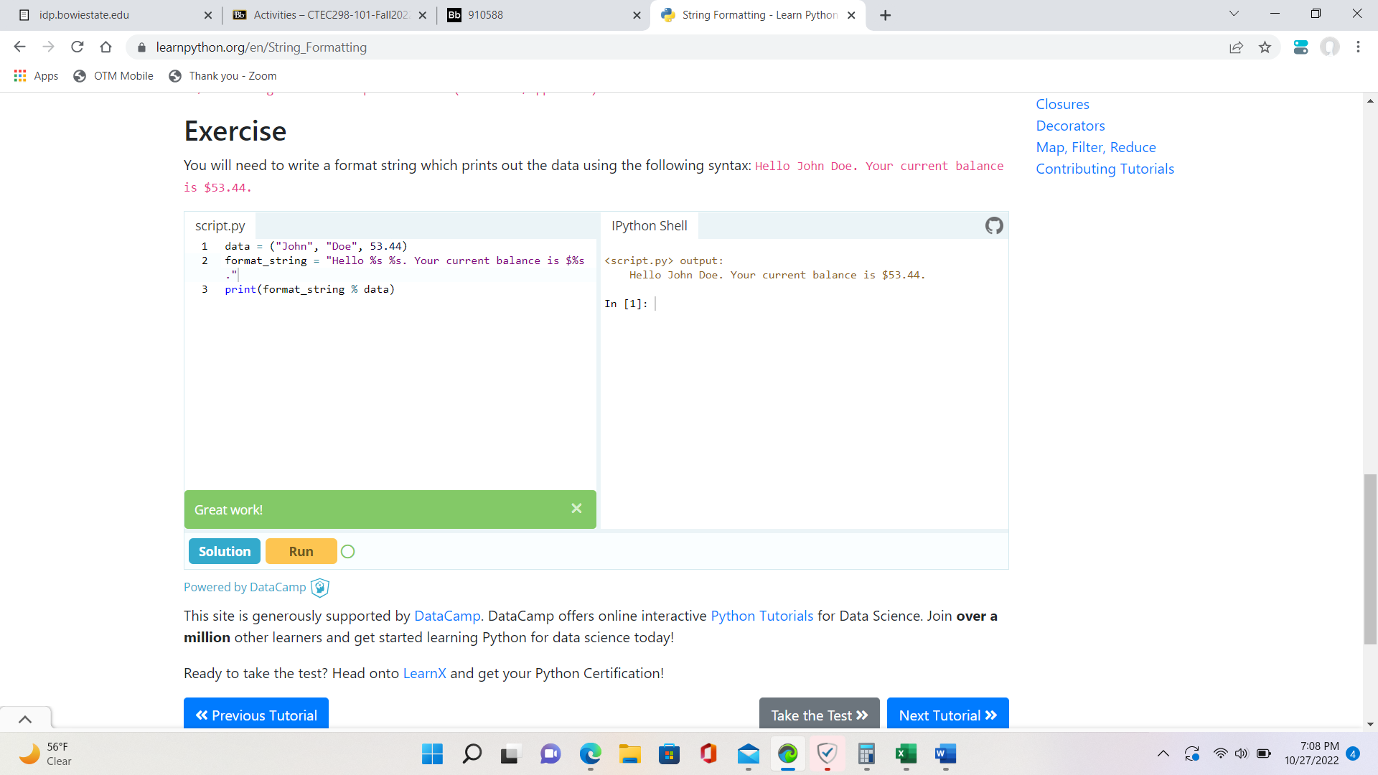

Basic String Operations

